Covid Information Champions Information Sheet Issue 14 Supplement

Rapid test home kits selfie campaign
As of 9 April, everyone in England is now able to access twice weekly rapid tests for coronavirus. Twice weekly rapid testing enables us to find asymptomatic cases and prevent the spread of infection. Getting into the habit of twice weekly testing as part of our everyday lives will help us all to play our part and do what we can to keep each other safe and alongside the vaccine ensure we can continue to ease our way out of lockdown. Up to one third of coronavirus cases are asymptomatic, meaning you could be carrying the virus and spreading it to your loved ones without realising it.
You can find your nearest collection site or order online to be delivered to your home at: www.hertfordshire.gov.uk/rapidtest
Our ask
We really want to normalise these twice weekly rapid tests, for people to take them when they know they are going to the pub garden, sitting with their family outside or even going for a haircut. They help keep us all safe and give us the reassurance that we will not be spreading it as we start to go out and socialise with more people.
Our campaign will feature a range of selfies from our Covid Information Champions, social media followers and Hertfordshire County Council staff members. The selfies ideally need to have the home kit box in the background and be of you taking the swab test up your nose. It can be as serious or as silly as you’d like, but we hope to get a good range of images shared as a polaroid with a caption underneath. The caption will be whatever the reason you are doing the rapid test e.g. “Afternoon tea at Nan’s”, “Night at the pub!” or “Off to football training”.
Below is an example of a home test selfie, with the caption “Looking forward to seeing you later for drinks”

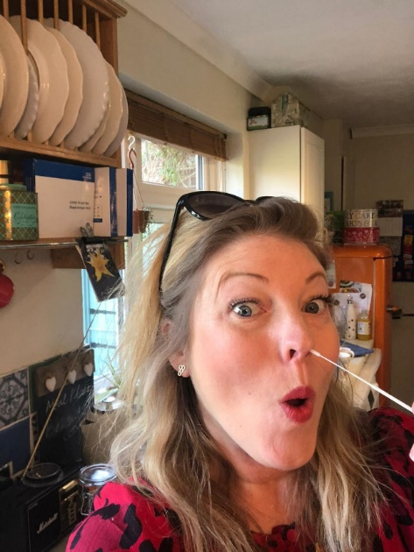

Selfies should be sent to: corporate.communications@hertfordshire .gov.uk with the subject line ‘Rapid Test Selfie’

