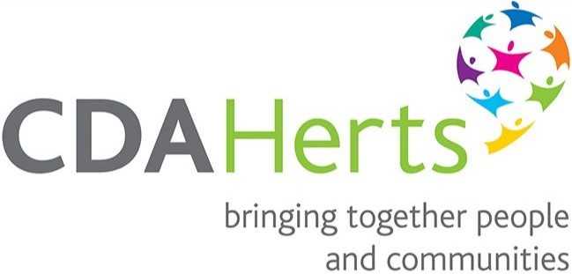

Herts Village Halls & Community Buildings Consortium

Annual Meeting & Conference 2022

Friday 25 November 9am - 2pm at Little Hadham Village Hall SG11 2BP

Programme

09.00 Registration and Refreshments

09.30 Welcome and Introductions – John Harwood-Bee, Tim Hayward-Smith

09.45 Session 1: 1. ACRE Village Halls Week 2023 – Philip Vincent 2. Energy Price Shock! – John Clemow
3. Combating Rising Energy Costs– Emily Berry, Utility Aid
4. Samaritans & Rural Outreach – Alister Martin
5. Safeguarding and UKGDPR – Tim Hayward-Smith

11.00 Our Sponsors and Supporters: Utility Aid, Norris & Fisher, Flooring Solutions and Maintenance Ltd, Sound Reduction Systems, Lemon Booking, Samaritans, Citizens Advice EH, Herts Sports Partnership, CDA Herts & CRED Project, Heating Save, University of Hertfordshire, Steel Plan Kitchens

11.10 Refreshments Break and Market Place

11.40 Session 2: 6. Forever Cycling – Adam Howard, Active In East Herts

12.00 Session 3: 7. A Solar PV Scheme – Barbara Kazwini, Kimpton Memorial Hall
8. A Warm Welcome – Tim Hayward-Smith
9. Community Wellbeing – Joan McKinlay Little Hadham Village Hall
10. A Rural Digital Café – Stuart Izzard, Benington Village Hall

12.40 East Herts VH&CB Consortium Annual Meeting and Elections

13.00 Buffet Lunch, Market Place and Networking

14.00 Close

Book your Place: https://www.eventbrite.co.uk/e/herts-village-halls-community-buildings-annual-meeting-and-conference-tickets-8687110381

Join on Zoom: https://us02web.zoom.us/j/84142682124

(Content may change without notice – apologies for any disappointment)

------------------------------------------------------------------------------------------------------------------------
Flooring Solutions and Maintenance

