Our Aims:
- To widen participation in debate and decision-making about rural matters in Hertfordshire.
- To give Hertfordshire’s rural businesses and communities a collective voice to bring about positive change.
- To fill the communications gap with Hertfordshire’s Public bodies since the demise of the Herts Rural Forum.
Priorities:
- To represent the interests of rural communities and rural businesses in Hertfordshire.
- To make representations on issues affecting rural life and business.
- To encourage active networking between people, organisations and service providers and across all sectors.
- To promote and share rural best practice.
- To provide a forum for interaction and debate about areas of concern such as rural crime, farming, jobs and growth, affordable housing, services (shops, pubs etc), fuel poverty, energy, transport, broadband, landscape, nature and environment and rural health.
- To actively seek participation of diverse groups, organisations and individuals in the Network.
Activities:
- There is a ‘virtual’ Network which functions through a Google Group.
- The Network holds TWO themed meetings per year in rural locations. Past themes have been ‘Farmers and Farming’, ‘Rural Loneliness’ and
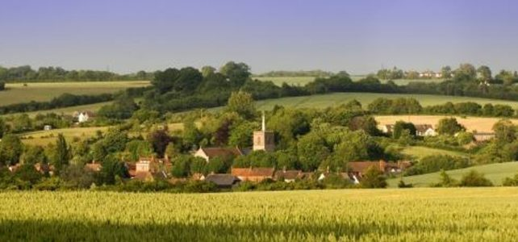
‘Community Shops and Pubs’.
TO JOIN - Contact tim.hayward-smith@cdaherts.org.uk Tel 01992 289054

